Creating jsonl file:
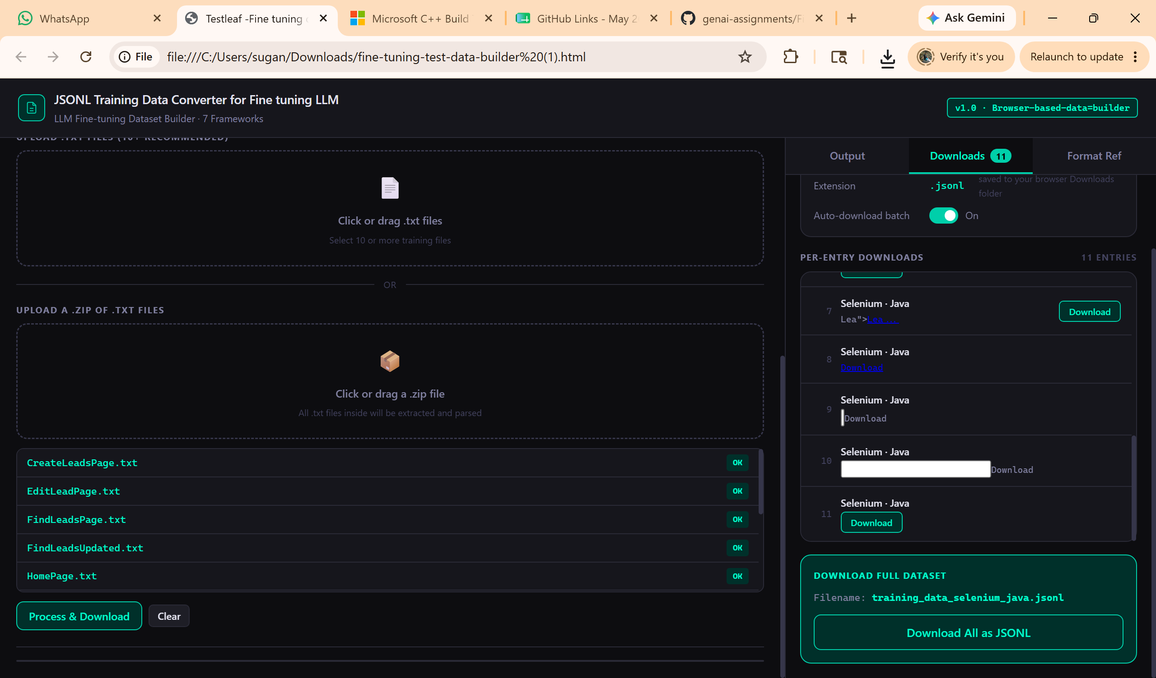
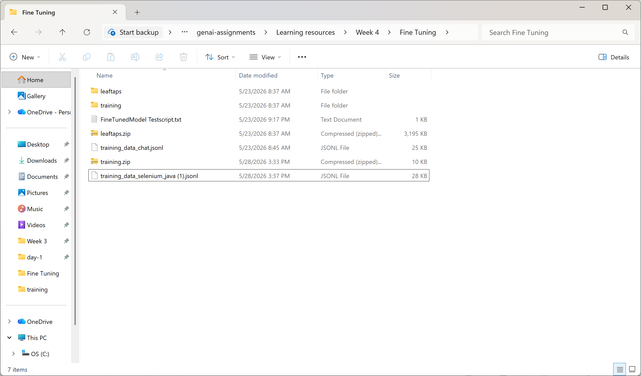
Creating fine tune model
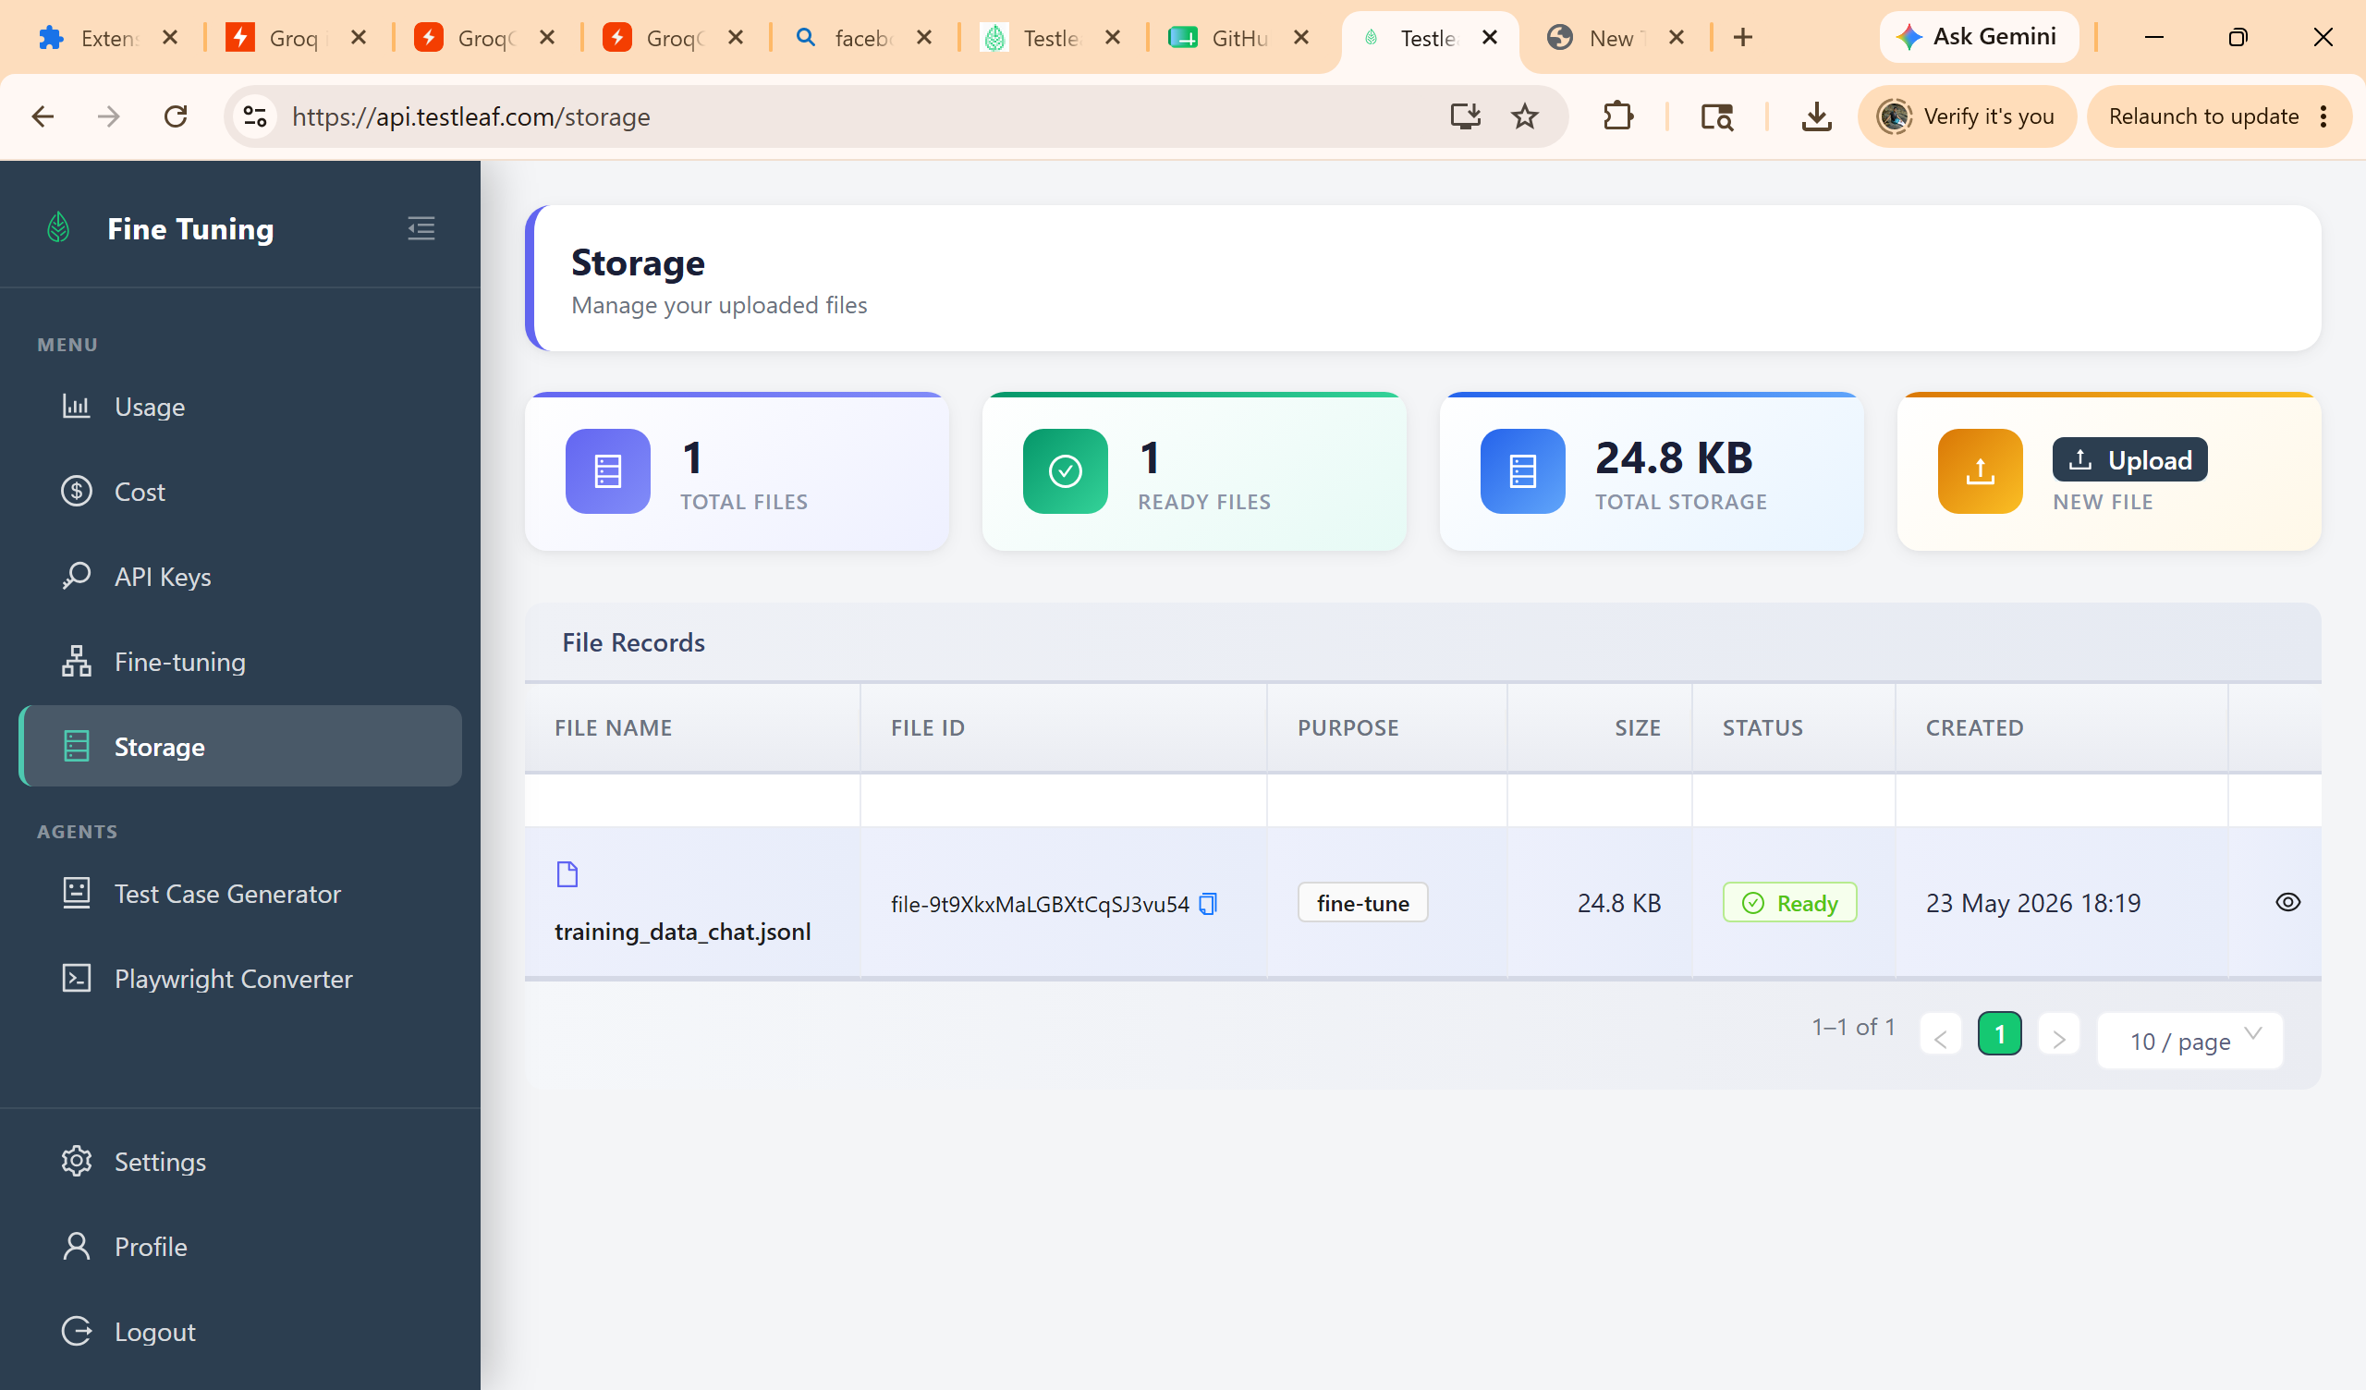
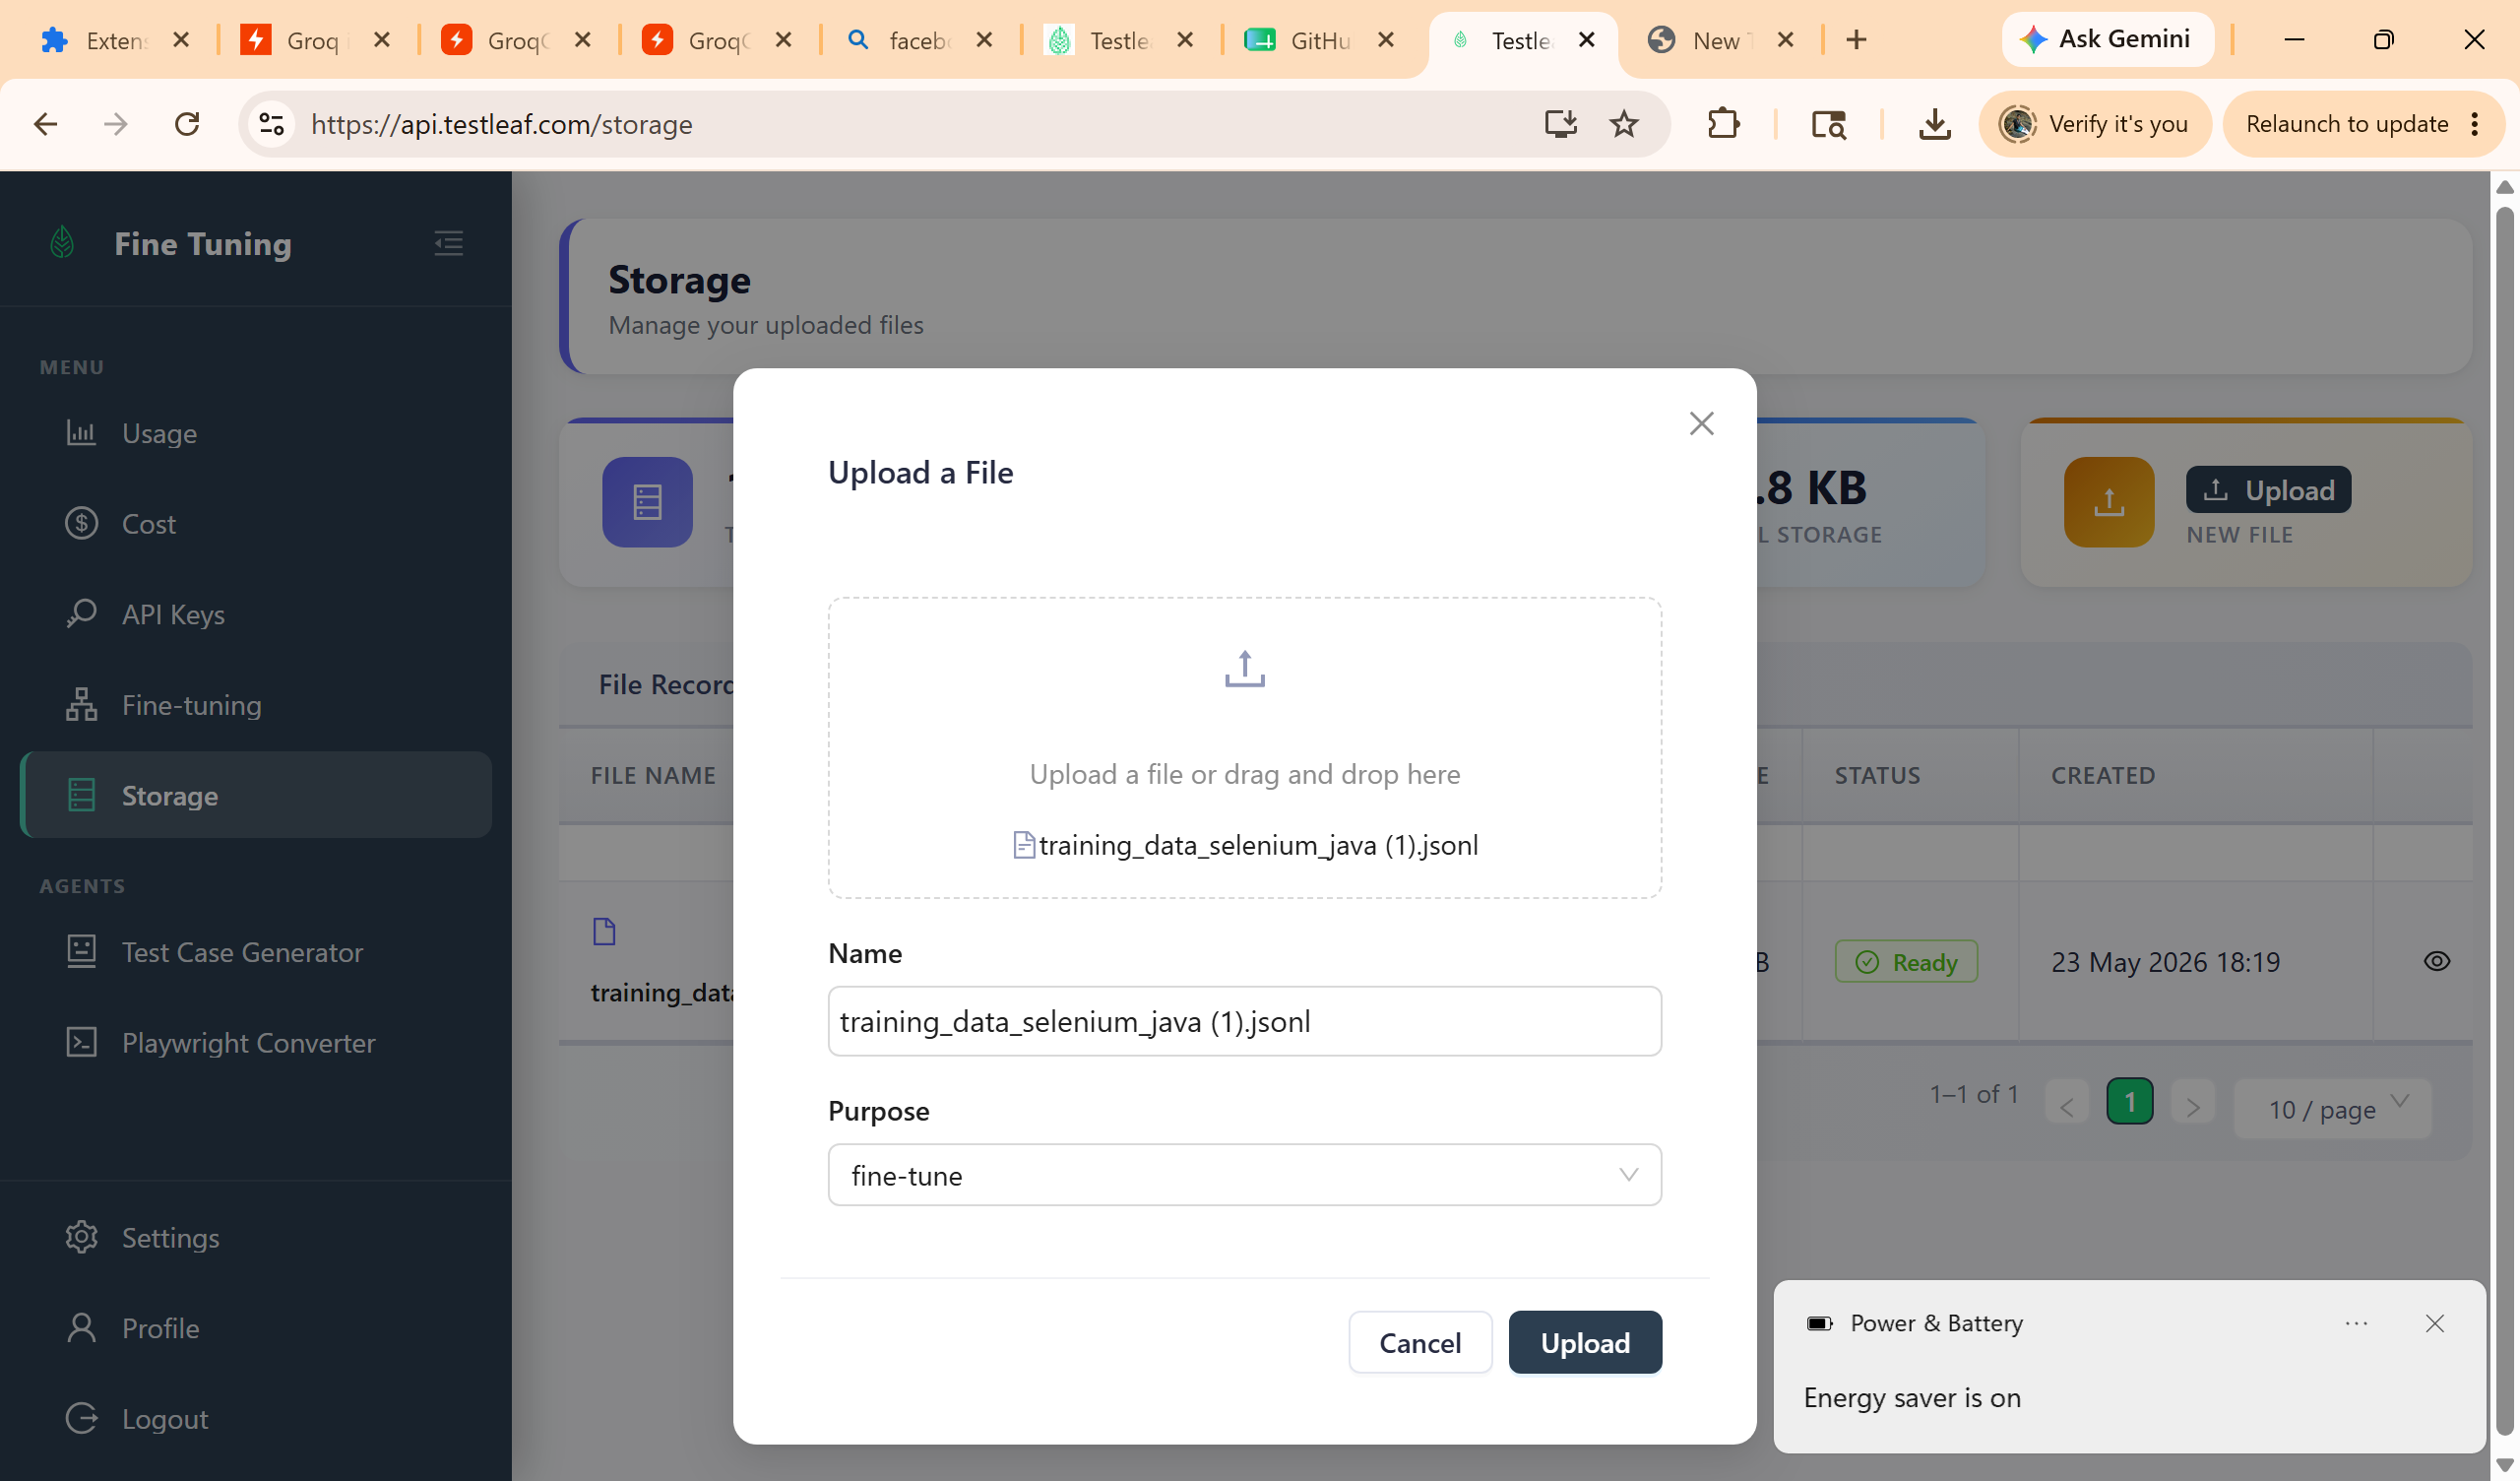
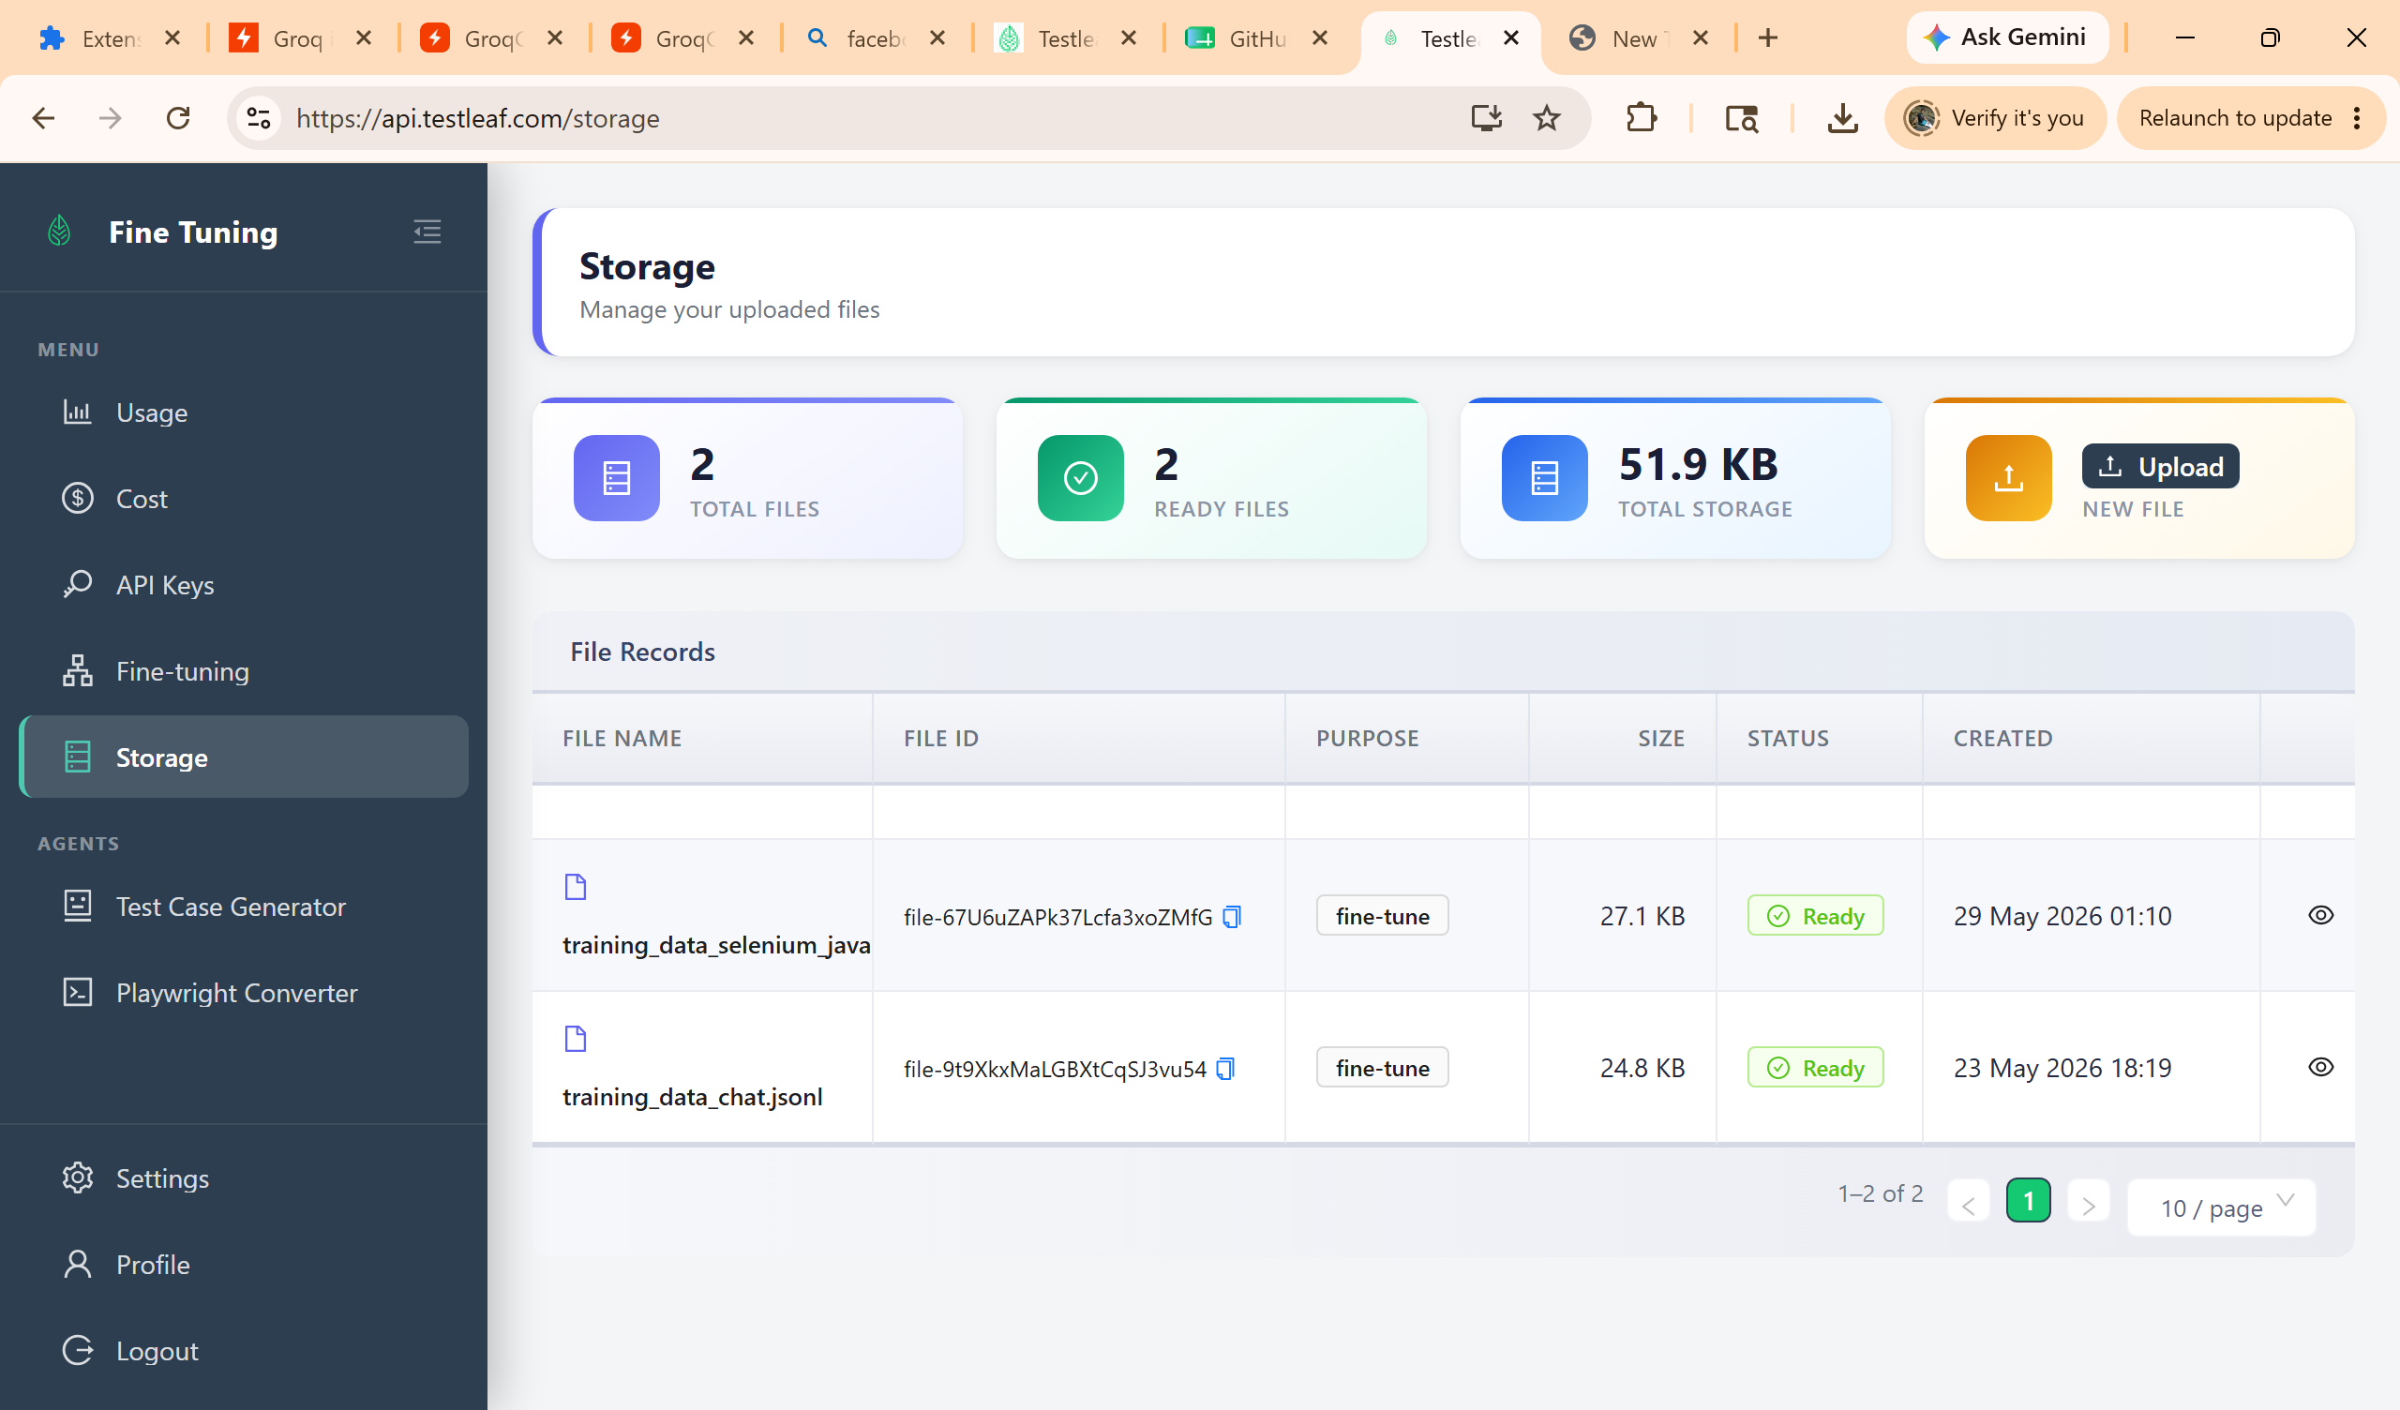
Fine tuning
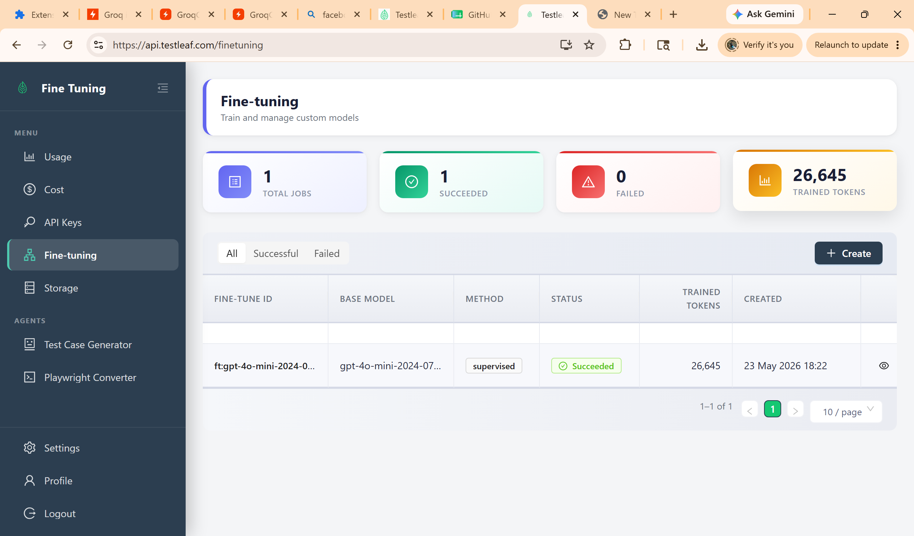
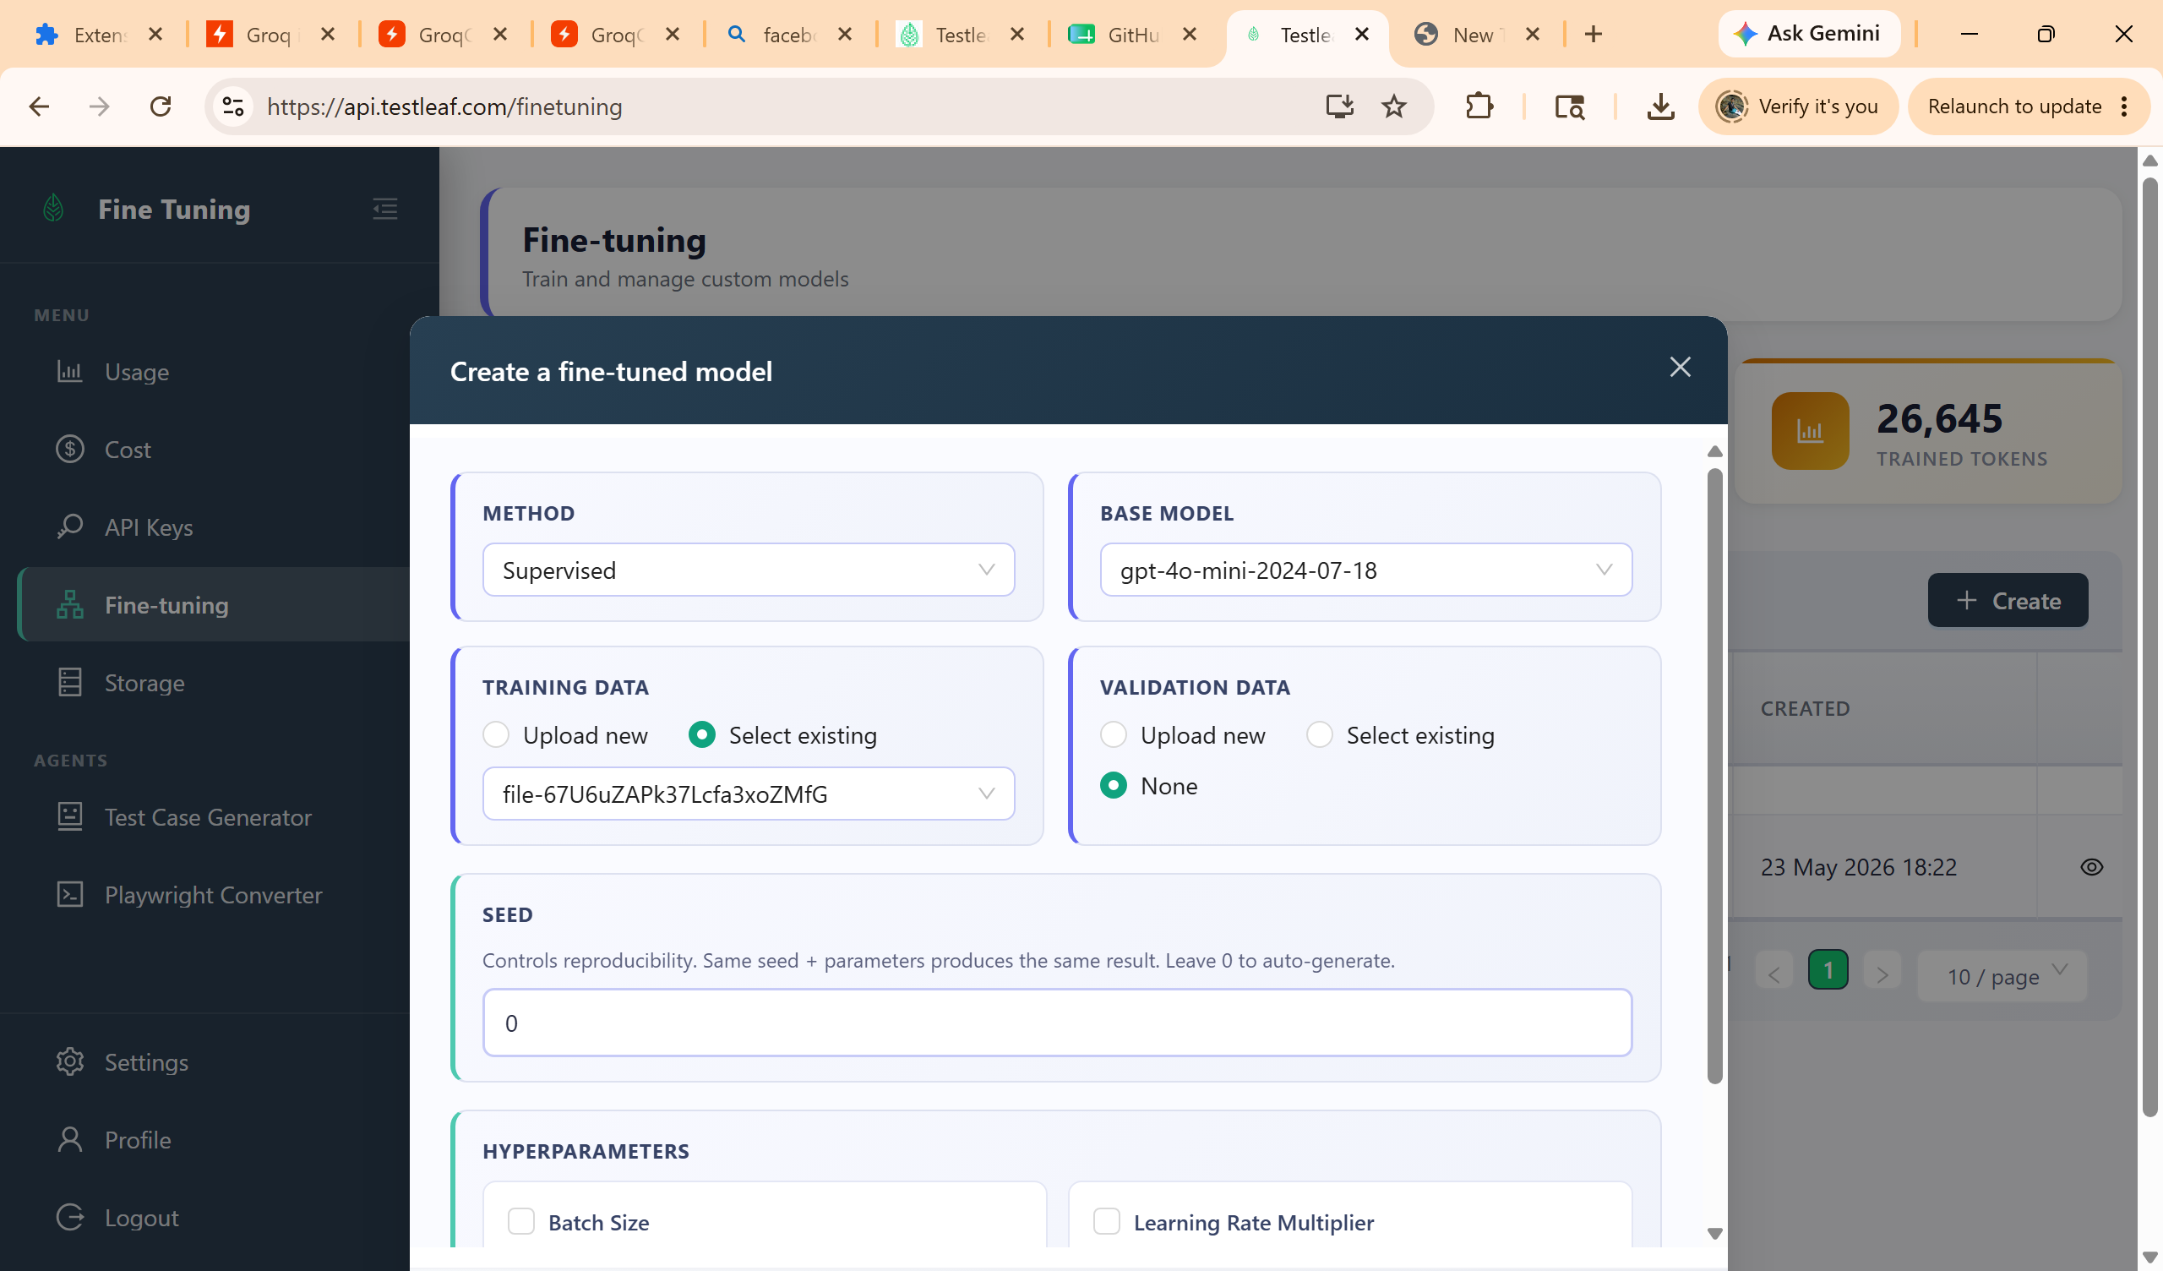
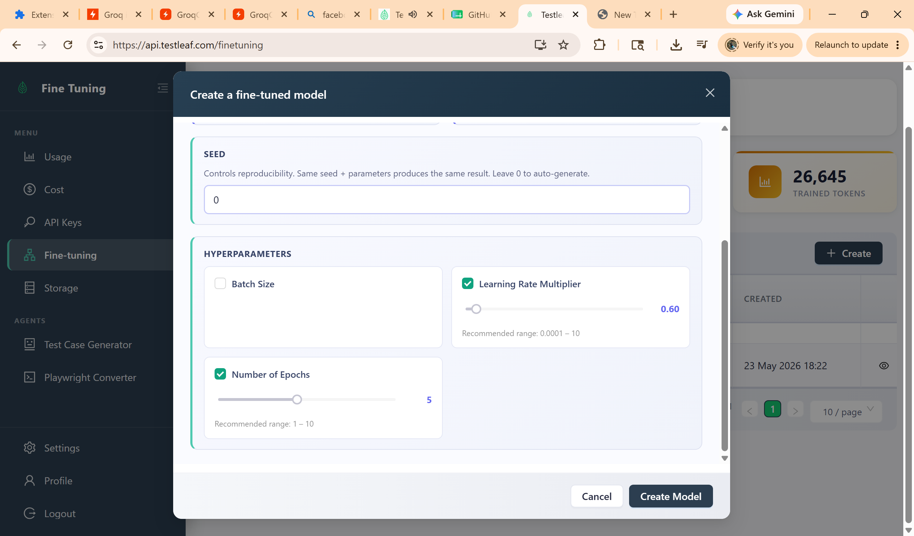
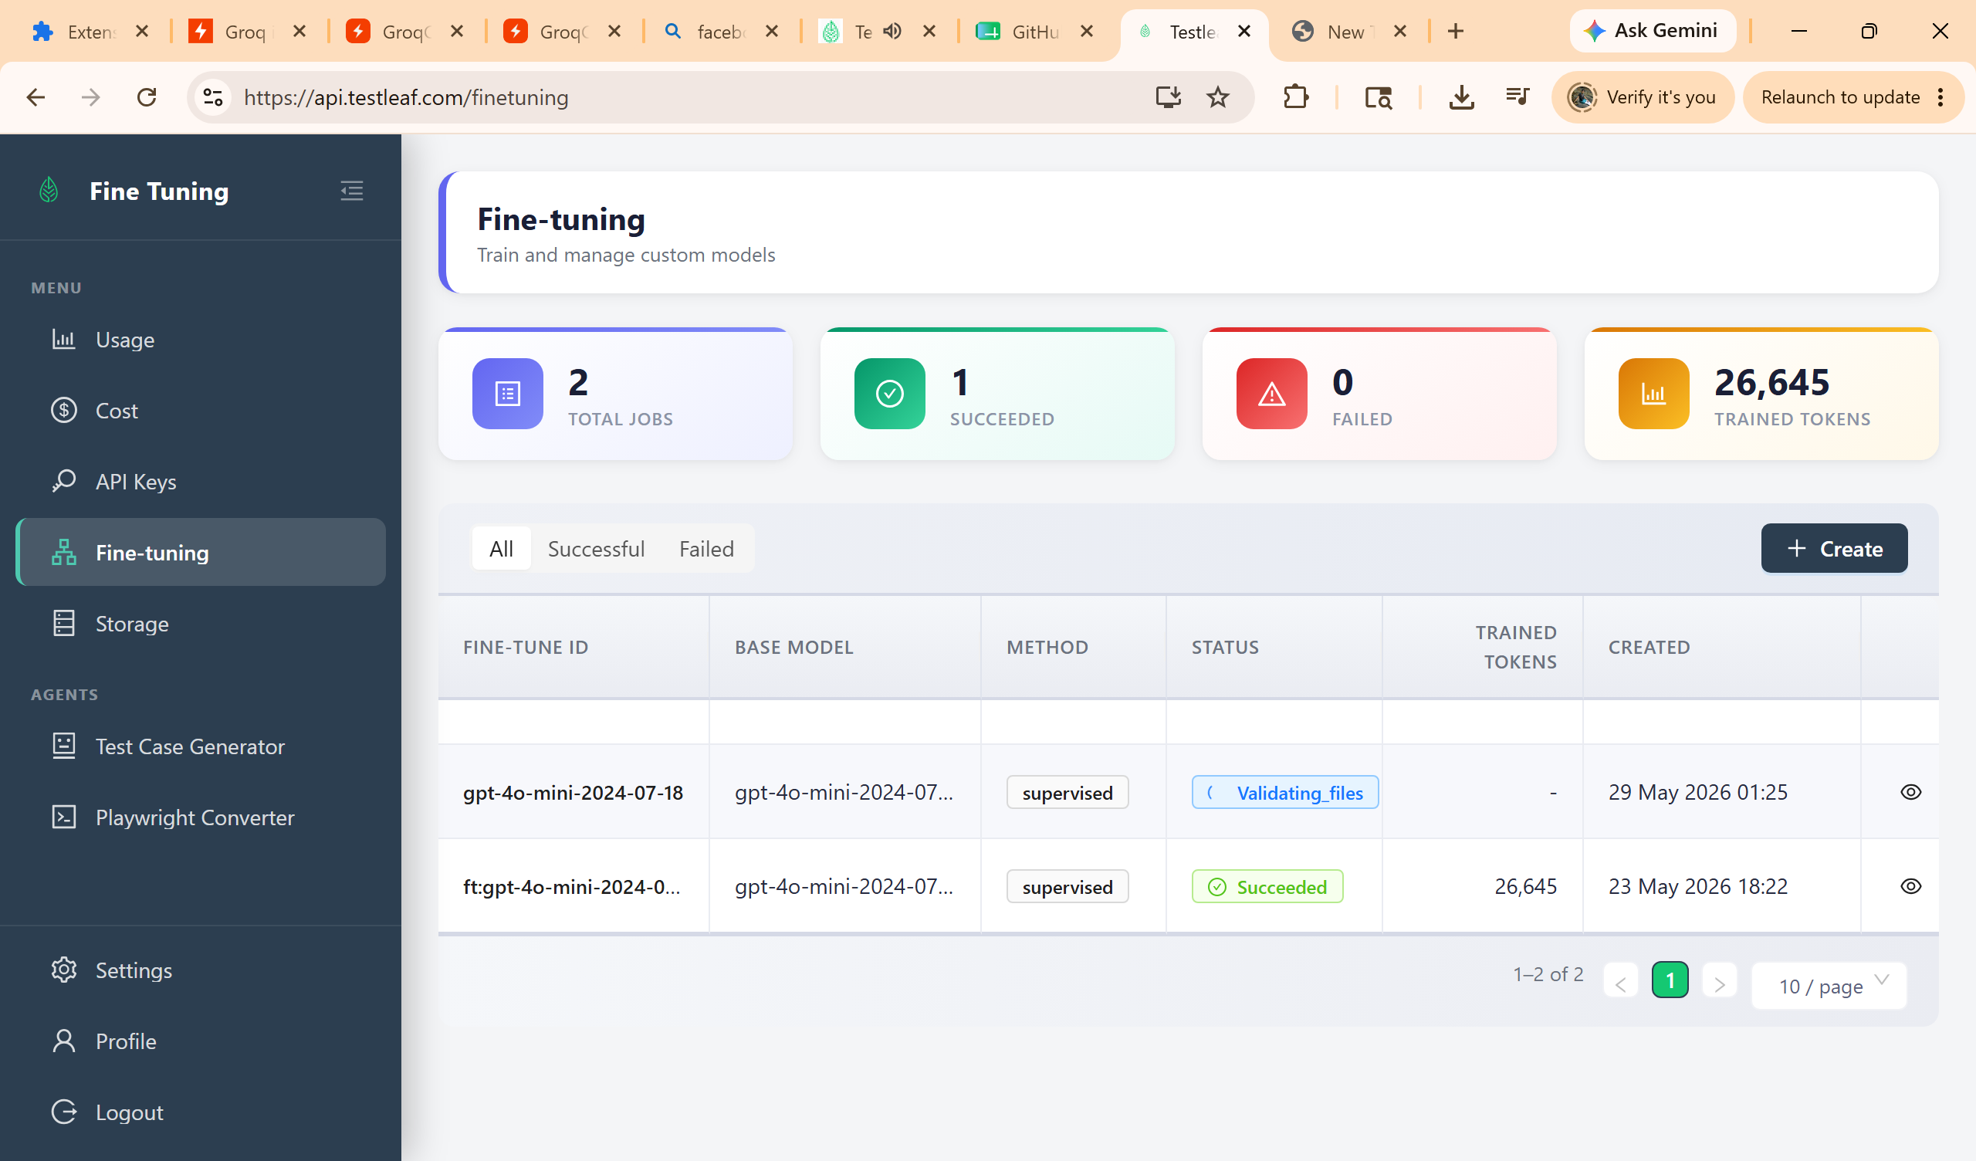
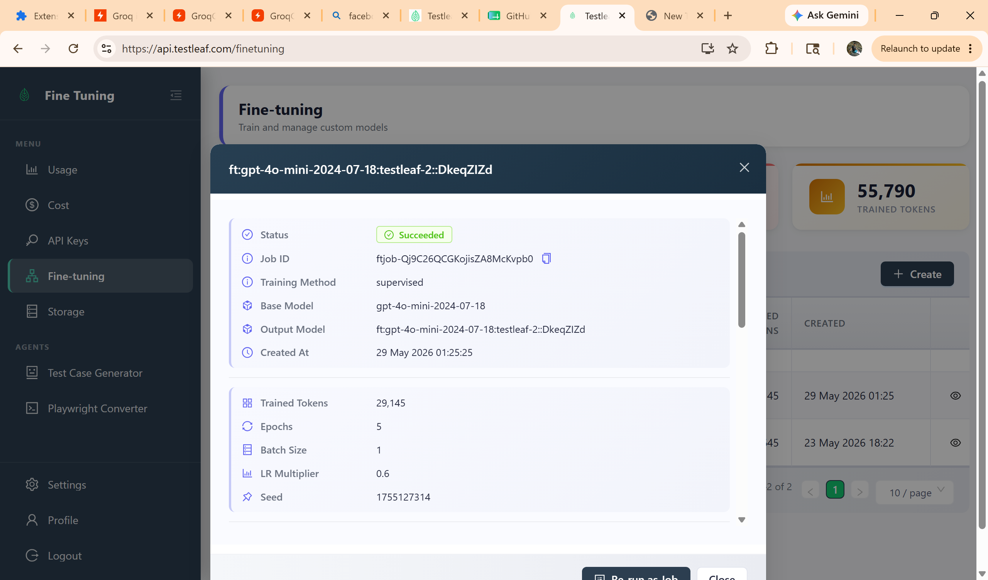
Popup.js
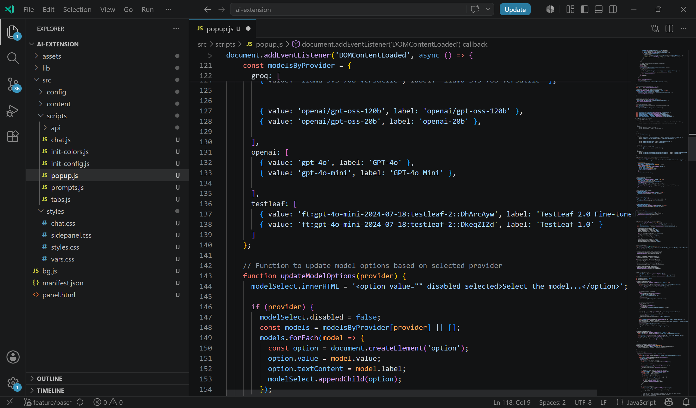
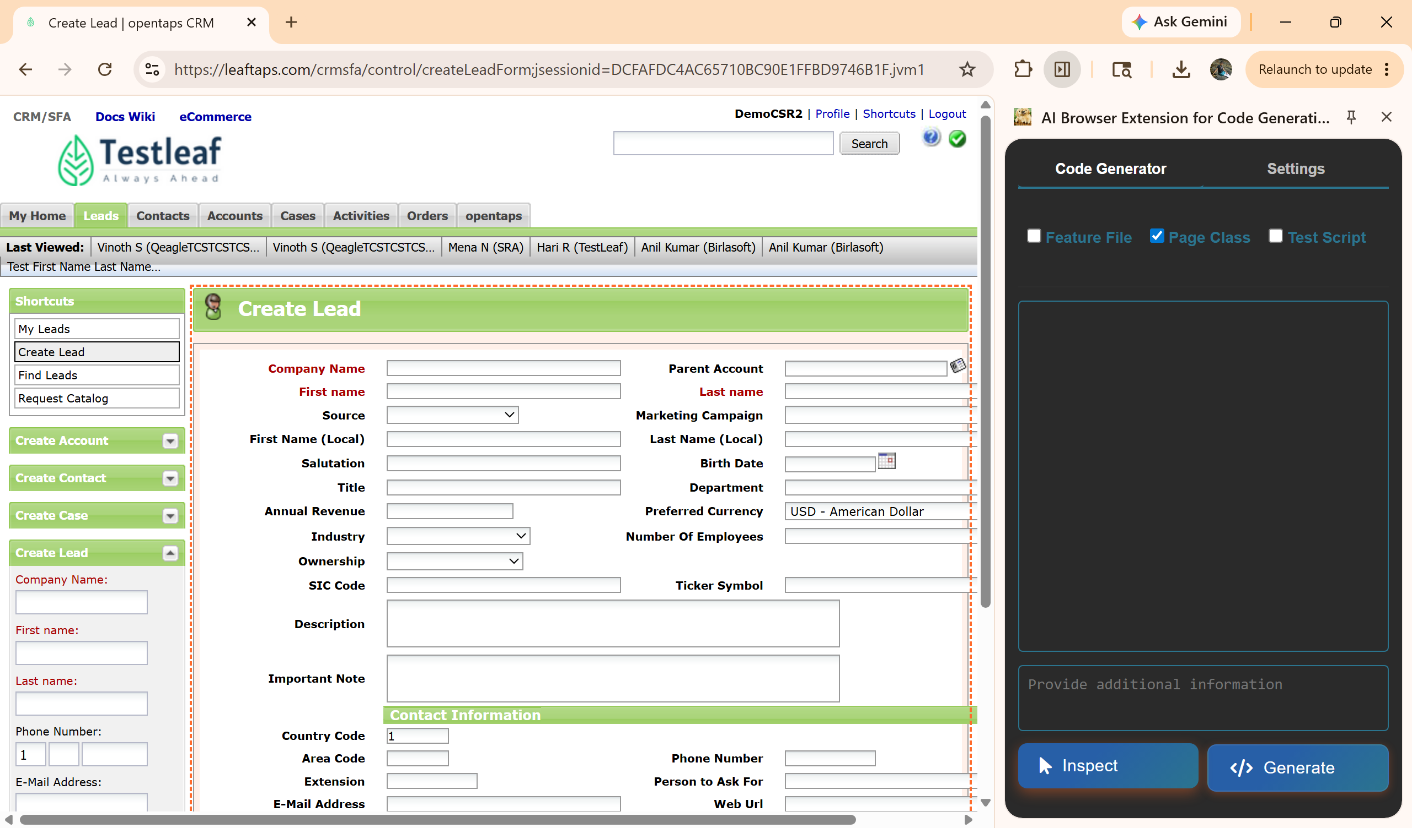
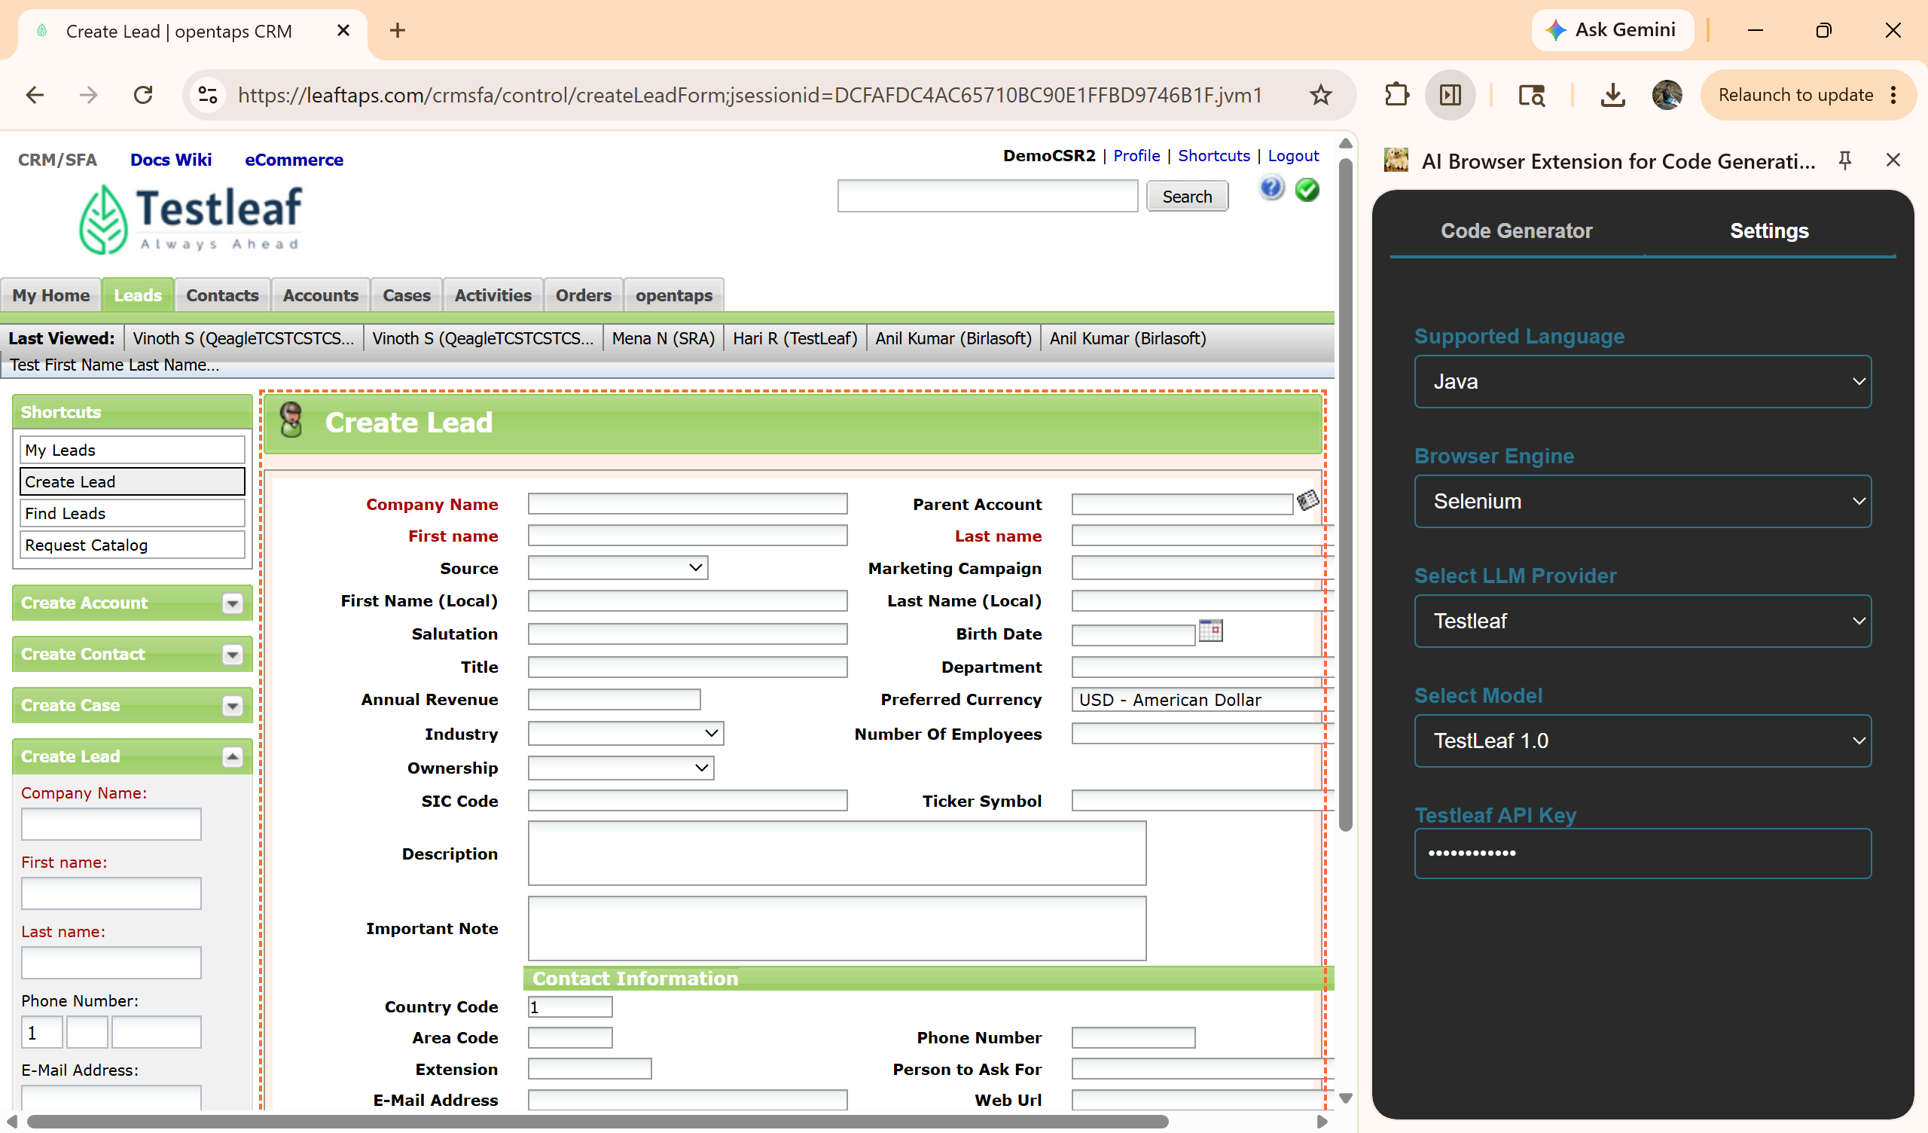
Page class file:
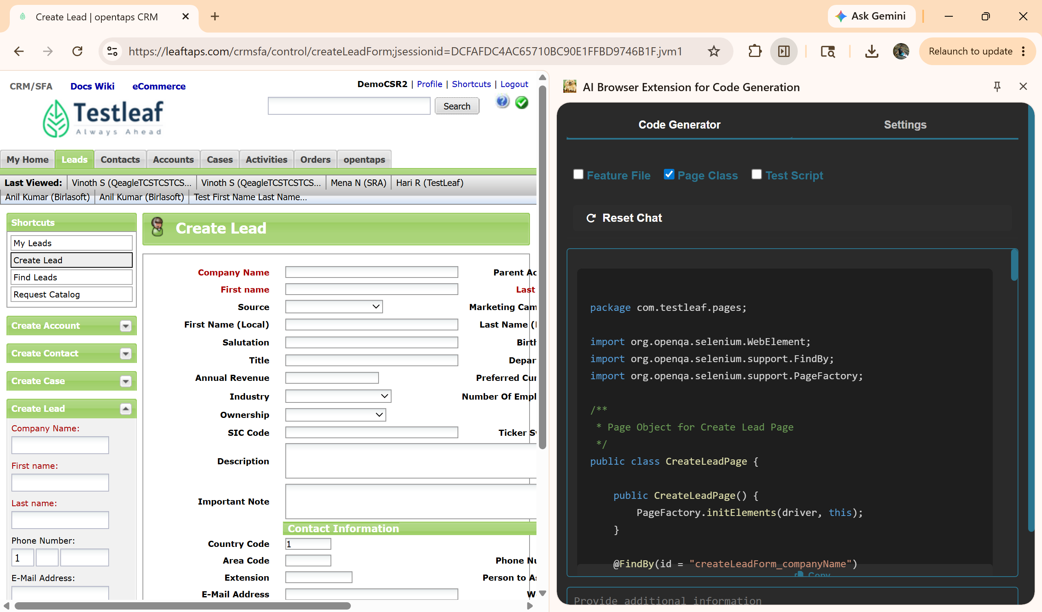
Fine tuned Page class file:
package com.testleaf.pages;

import org.openqa.selenium.WebElement;
import org.openqa.selenium.support.FindBy;
import org.openqa.selenium.support.PageFactory;
import com.testleaf.selenium.api.base.ProjectSpecificMethods;

/**
* Page Object for Create Lead Page
* Provides methods to interact with the Create Lead form.
*
* @author Auto-generated
*/
public class CreateLeadPage extends ProjectSpecificMethods {

/**
* Initializes the CreateLeadPage with the current driver.
*/
public CreateLeadPage() {
PageFactory.initElements(driver, this);
}

@FindBy(id = "createLeadForm_companyName")
private WebElement eleCompanyName;

@FindBy(id = "createLeadForm_firstName")
private WebElement eleFirstName;

@FindBy(id = "createLeadForm_lastName")
private WebElement eleLastName;

@FindBy(className = "smallSubmit")
private WebElement eleCreateLeadButton;

/**
* Enters the company name in the Create Lead form.
*
* @param companyName the company name to enter
* @return the current CreateLeadPage instance
*/
public CreateLeadPage enterCompanyName(String companyName) {
clearAndType(eleCompanyName, companyName);
reportStep(companyName + " company name entered successfully", "pass");
return this;
}

/**
* Enters the first name in the Create Lead form.
*
* @param firstName the first name to enter
* @return the current CreateLeadPage instance
*/
public CreateLeadPage enterFirstName(String firstName) {
clearAndType(eleFirstName, firstName);
reportStep(firstName + " first name entered successfully", "pass");
return this;
}

/**
* Enters the last name in the Create Lead form.
*
* @param lastName the last name to enter
* @return the current CreateLeadPage instance
*/
public CreateLeadPage enterLastName(String lastName) {
clearAndType(eleLastName, lastName);
reportStep(lastName + " last name entered successfully", "pass");
return this;
}

/**
* Clicks the Create Lead button to submit the form.
*
* @return the View Lead Page instance
*/
public ViewLeadPage clickCreateLeadButton() {
click(eleCreateLeadButton);
reportStep("Create Lead button clicked successfully", "pass");
return new ViewLeadPage();
}
}

